**DIODE BRIDGE**

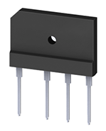

**INTRODUCTION:**

Diode Bridge is the bridge rectifier module. It converts AC signal into pulsating DC. It consist of bridge rectifier circuit. It is a great replacement for using 4 diodes.

**PINS DIAGRAM AND WORKING:**

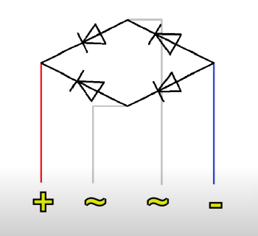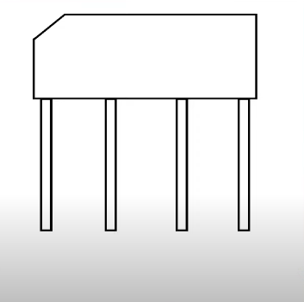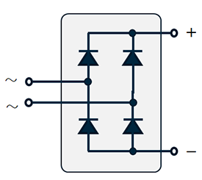



The Diode Bridge contains 4 diodes internally. Each diode bridge has 4 pins, two are used for AC inputs and other two for +ve and -ve output.